1. Homepage
   1. Menus

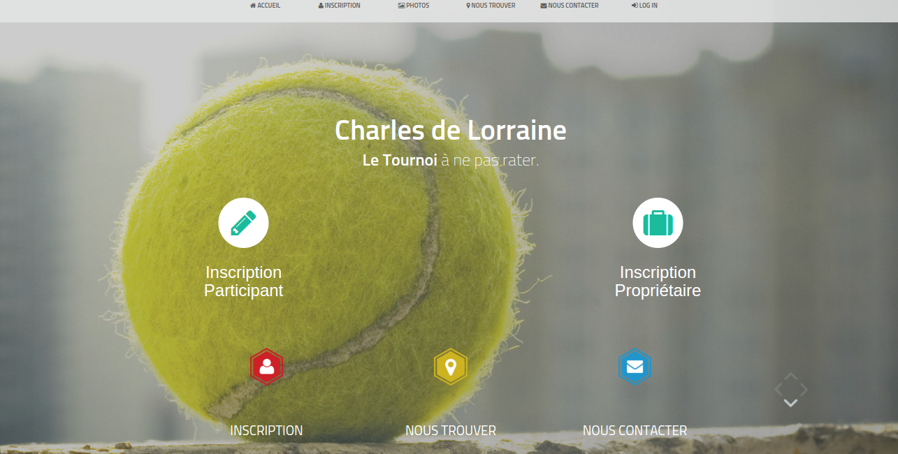

* 1. Presentation & Inscriptions

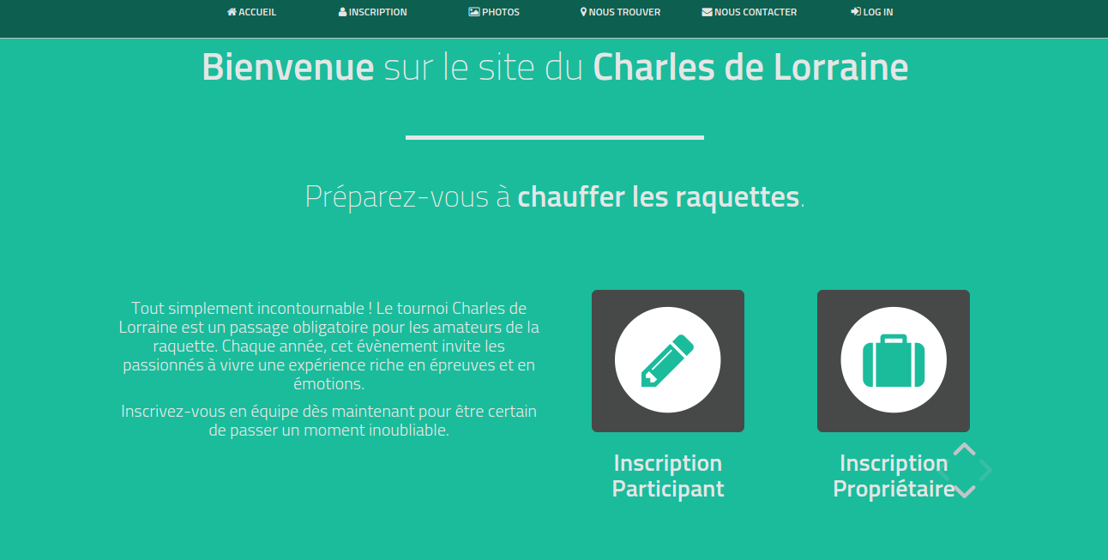

* 1. Pictures

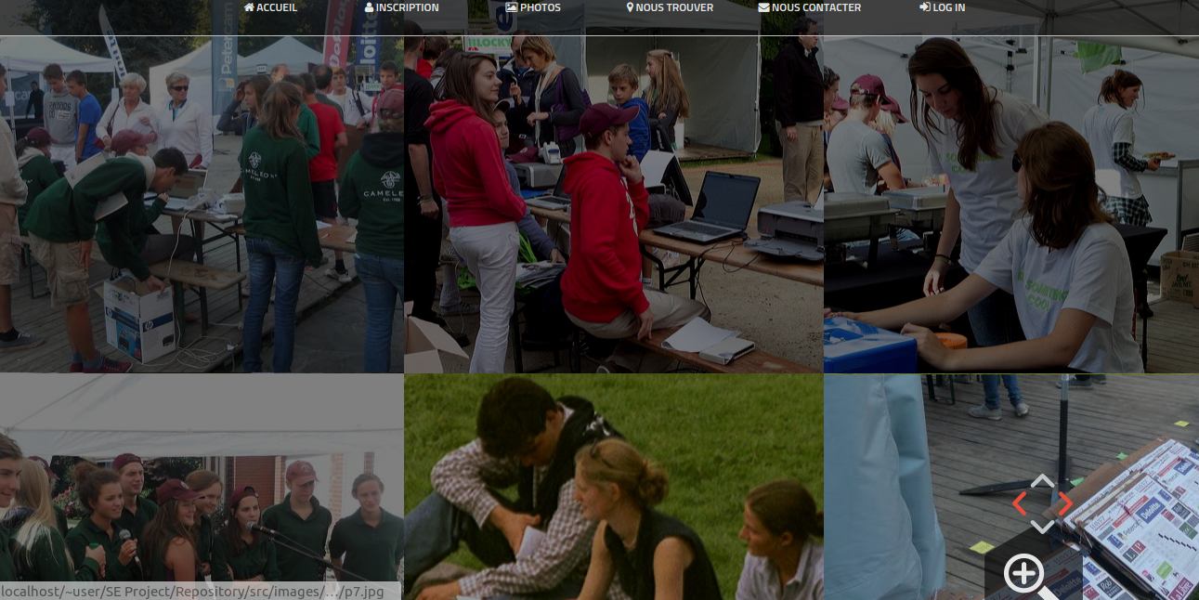

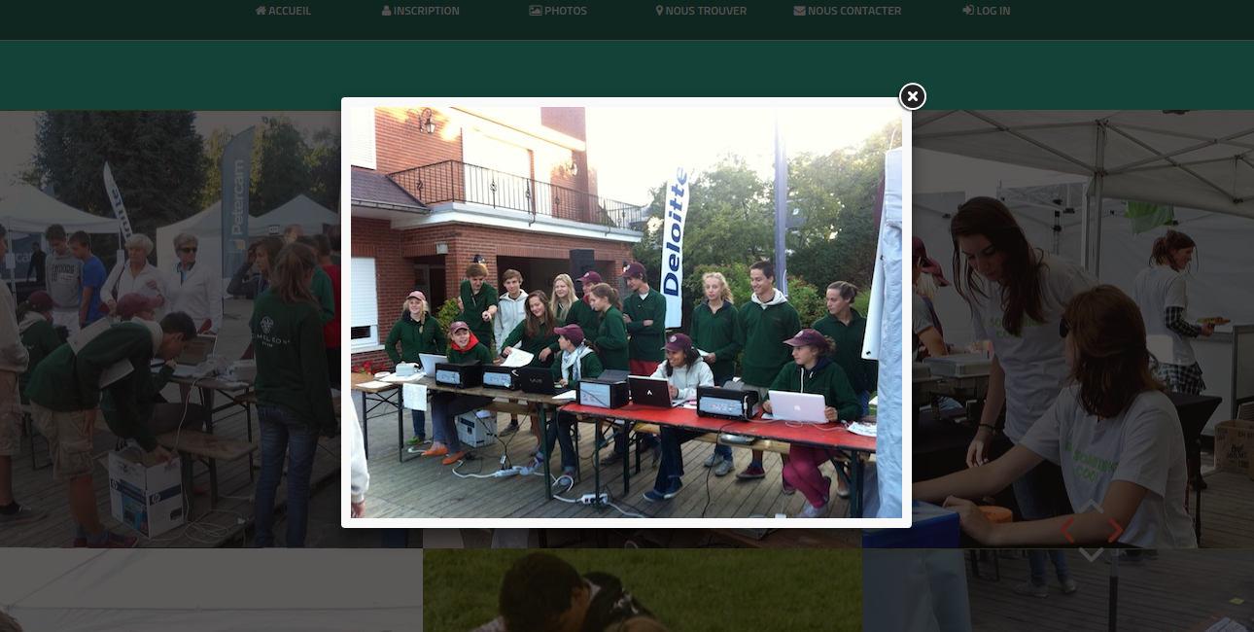

* 1. Where to find us ?

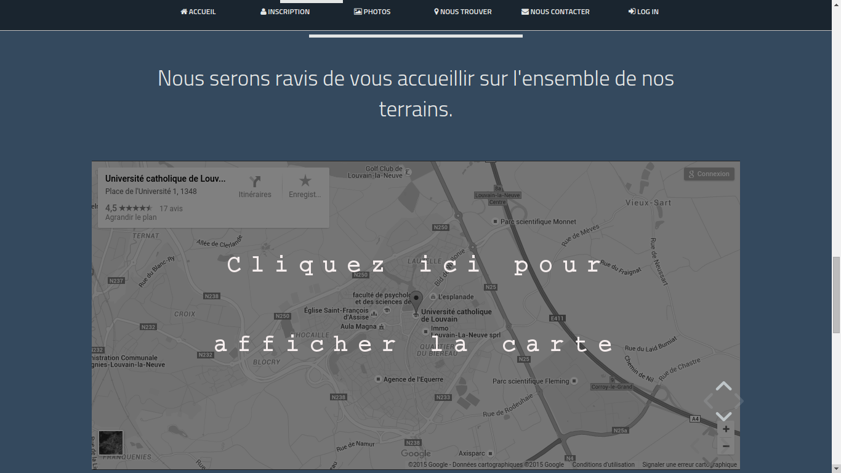

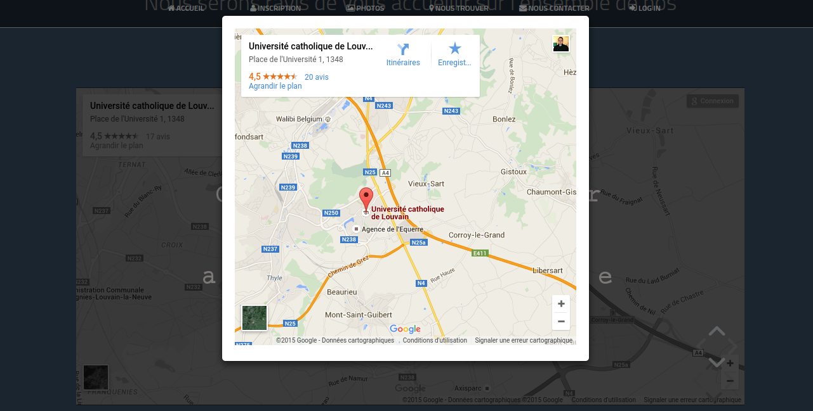

* 1. Contact

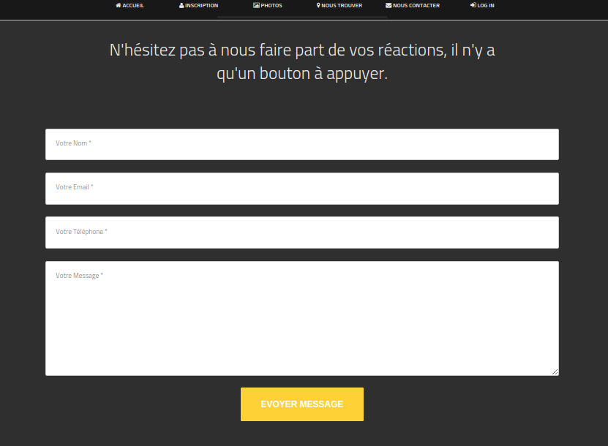

1. Inscriptions
   1. Inscription for 2 players

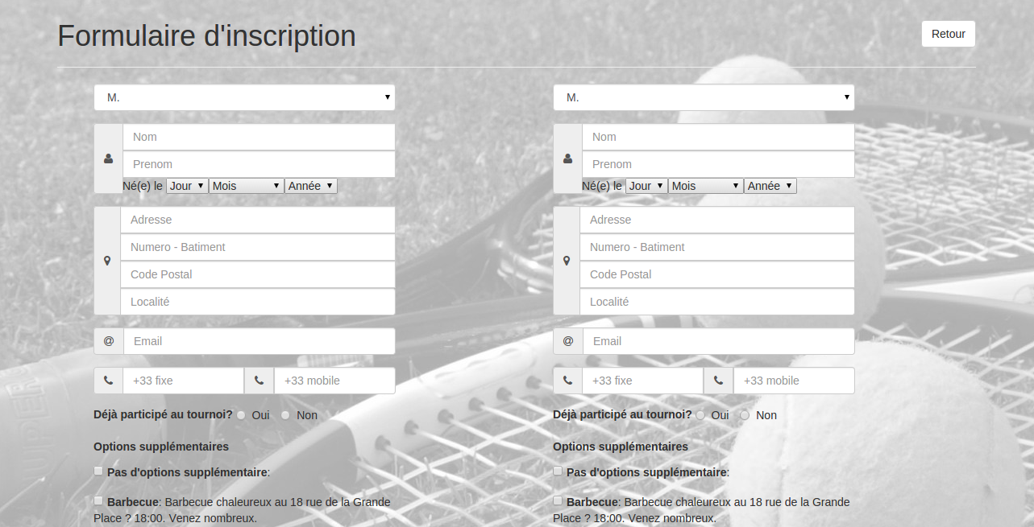

* 1. Inscription for owners

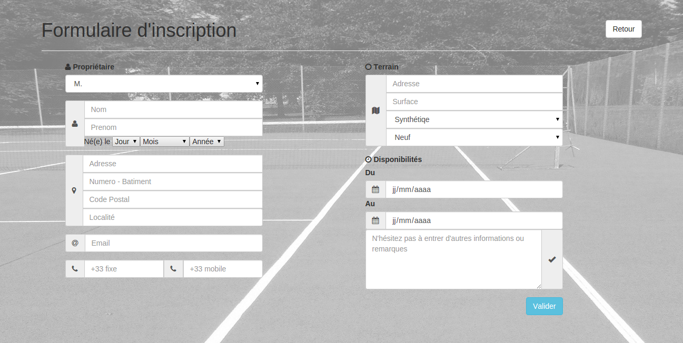

1. Staff Interface
   1. Log in

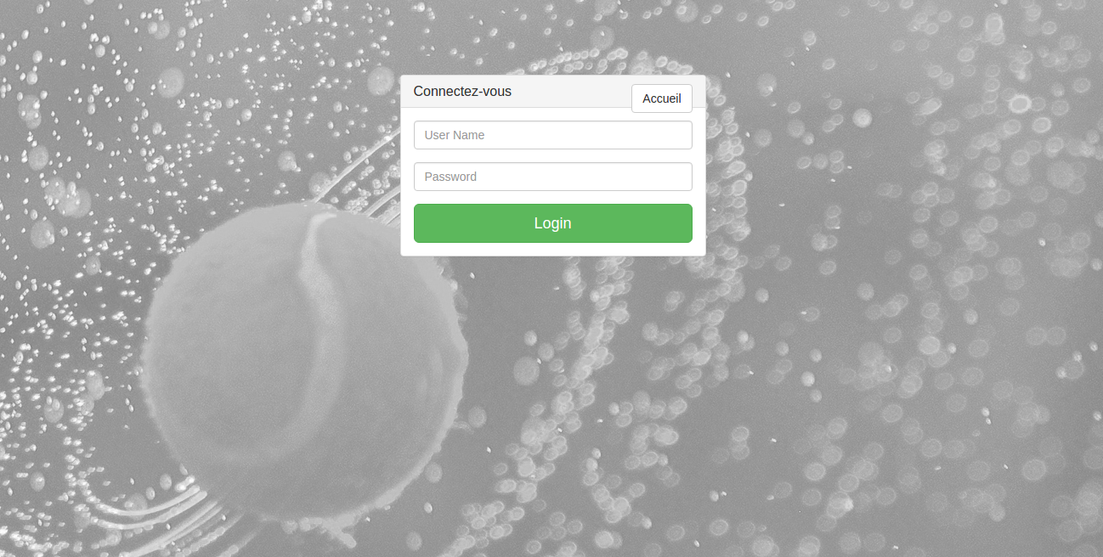

* 1. Home
     1. Menus

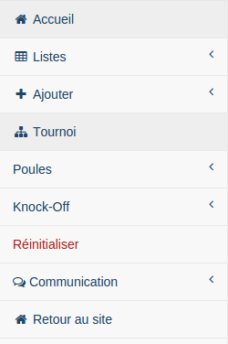

* + 1. Modification history

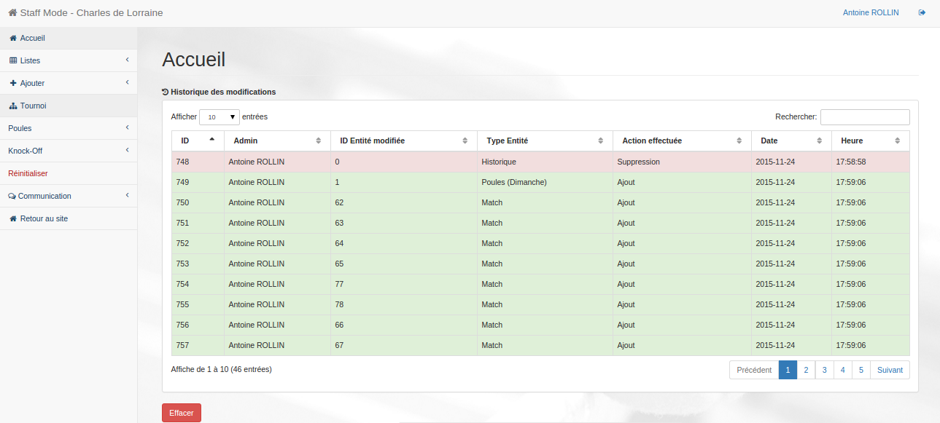

* 1. Lists

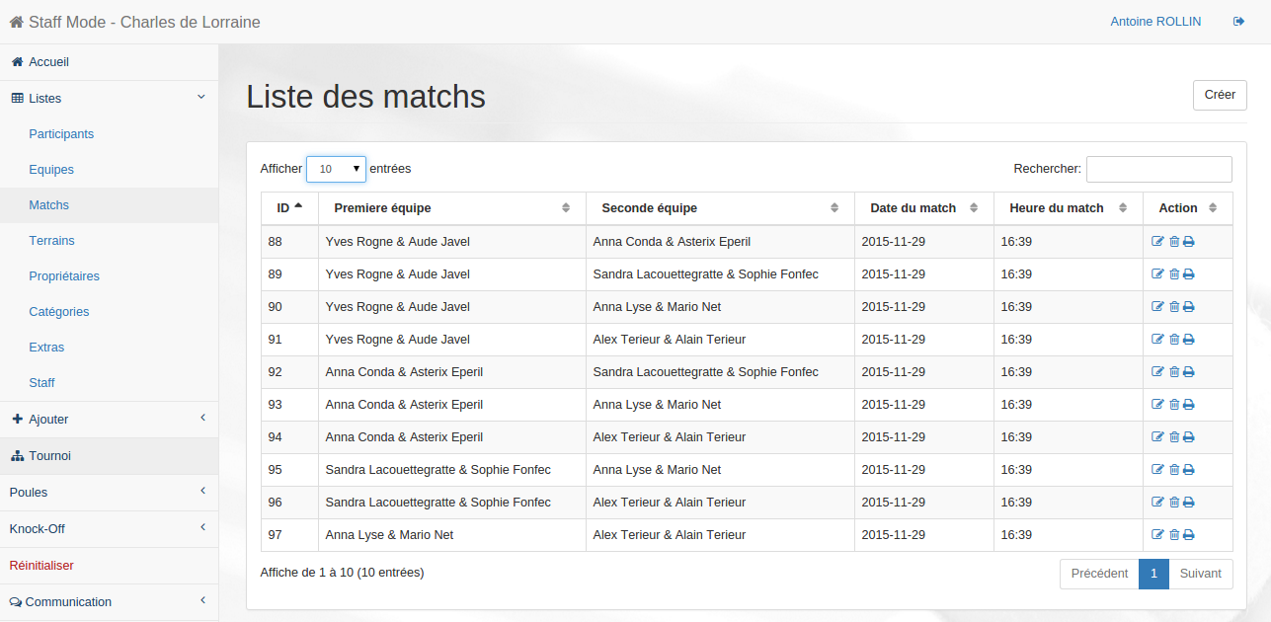

* + 1. Show

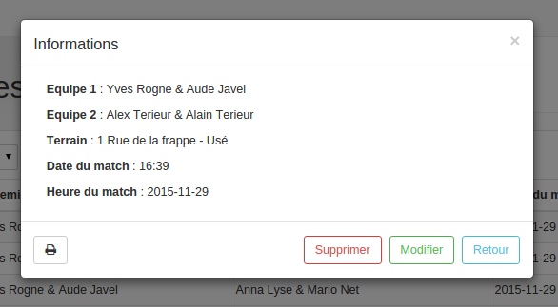

* + 1. Edition

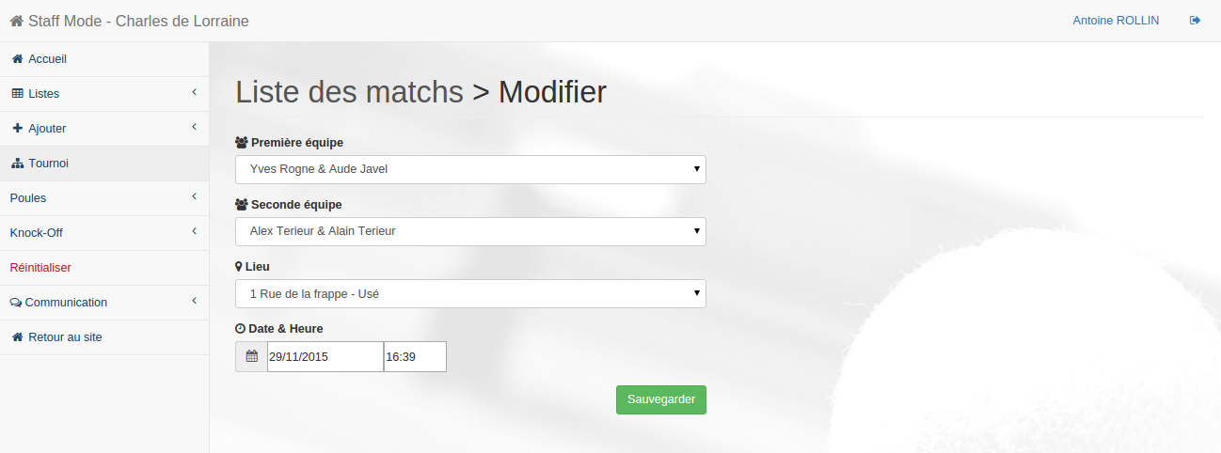

* + 1. Deletion
    2. Print (match only)

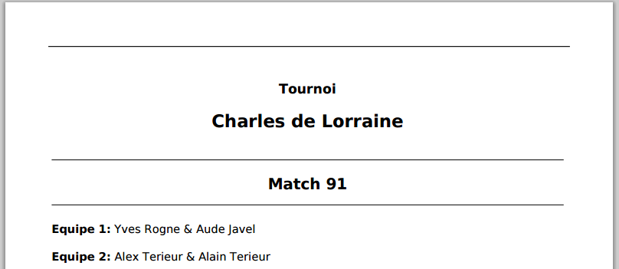

* 1. Add

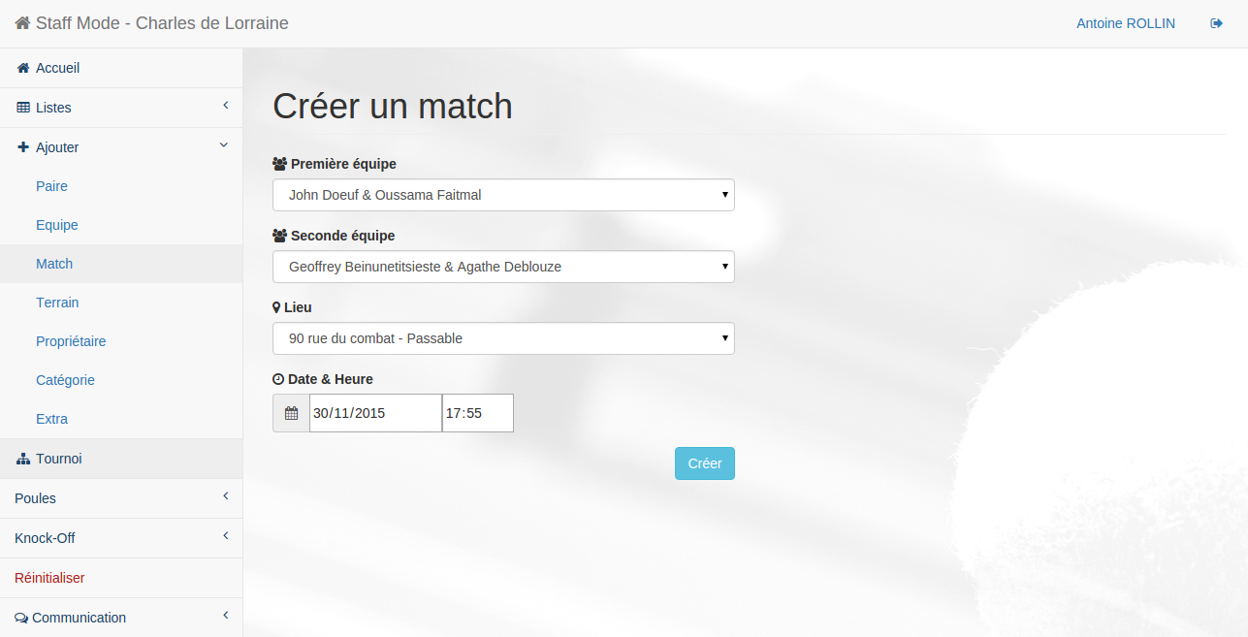

* 1. Tournament
     1. Groups
        1. Generation

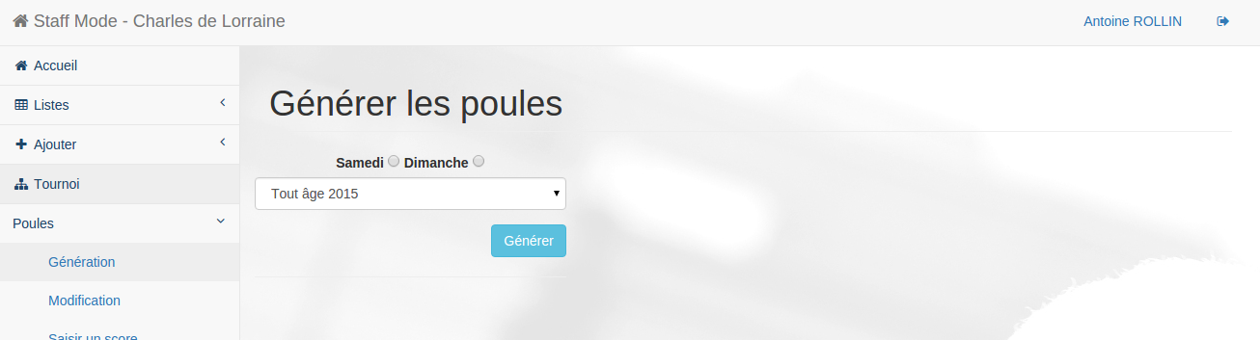

* + - 1. Modification

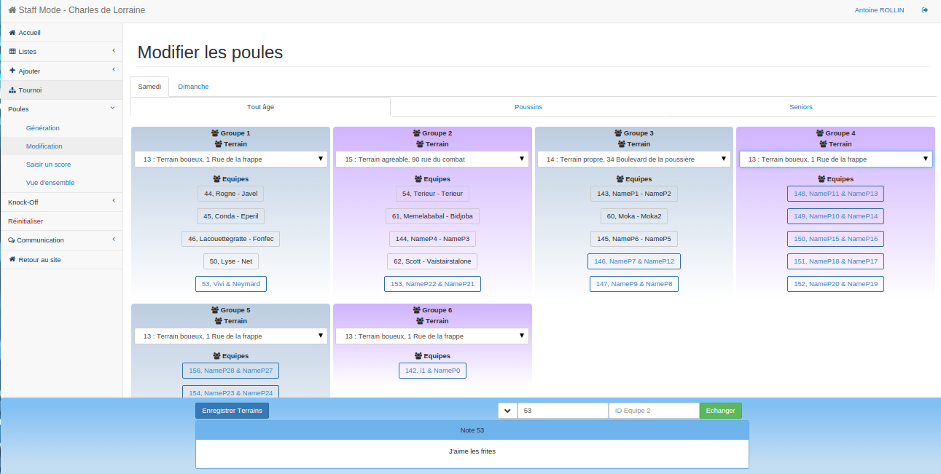

* + - 1. Enter a score

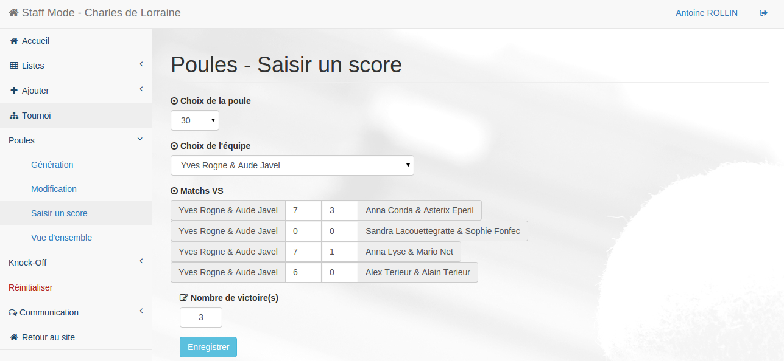

* + - 1. Overview
    1. Knock-Off
       1. Creation

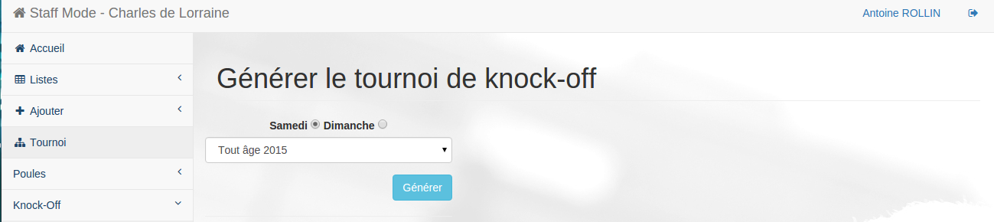

* + - 1. Modification
      2. Enter a score
      3. Results
    1. Reset

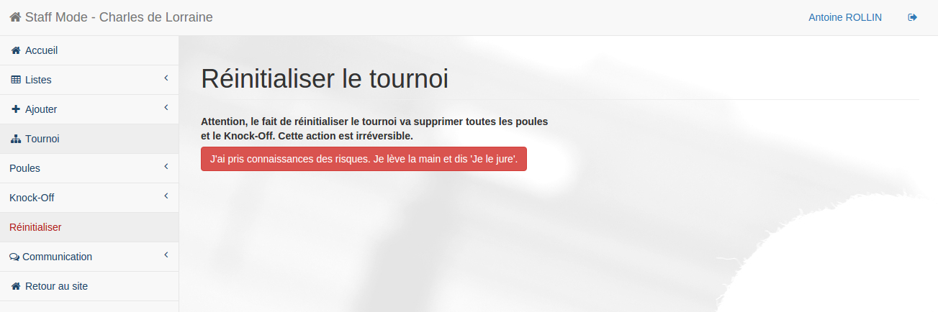

* 1. Communication
     1. Send a mail

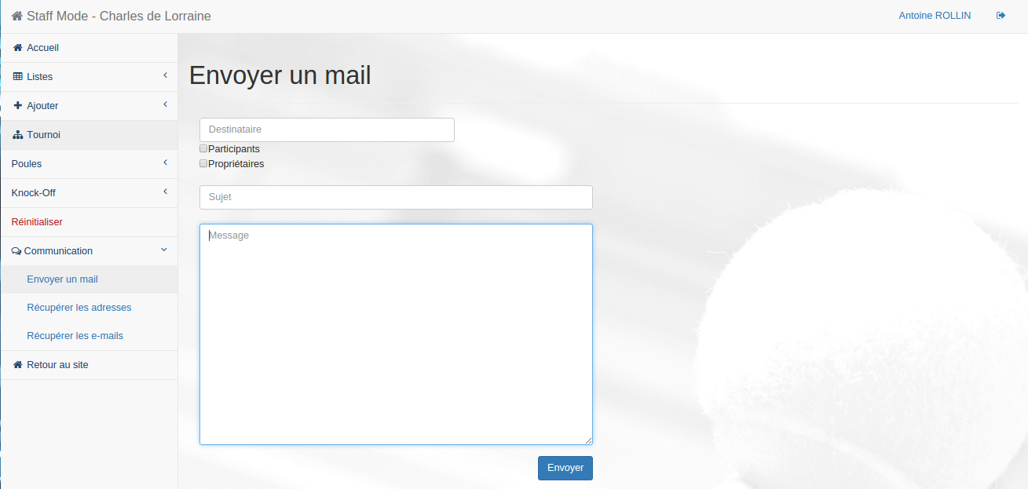

* + 1. Get addresses

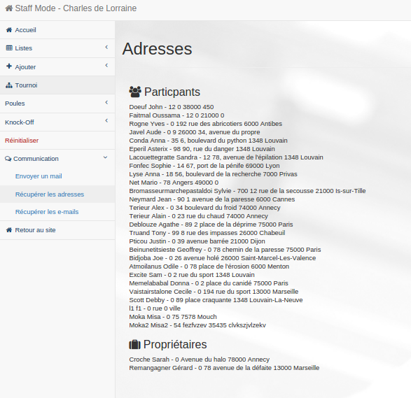

* + 1. Get mails

